Database System Engineering and Distributed Backend Development
Course Code: 25CS13002E
ROLL NO:2520030531
NAME: D. Venya Sri

BANK DATABASE – ACID PROPERTIES & ISOLATION
Query 1: Create Database
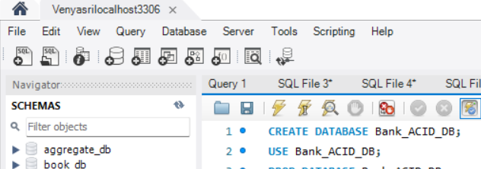
Output:
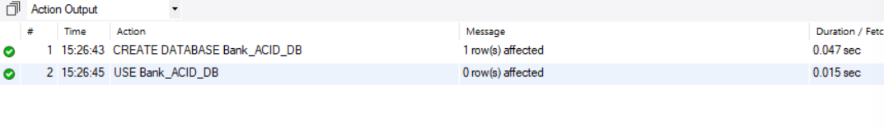
Query 2: CREATE CUSTOMER TABLE
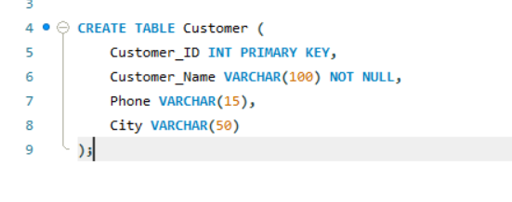
Output:

Query 3: CREATE ACCOUNT TABLE
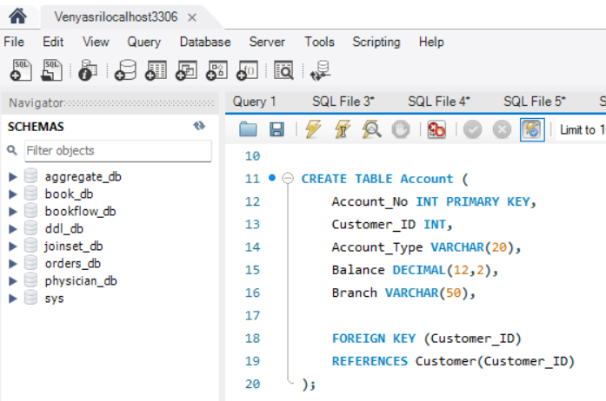
Output:

Query 4: CREATE TRANSACTION TABLE
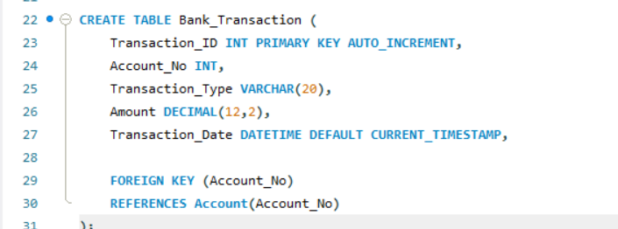
Output:

Query 5: INSERT CUSTOMER DATA
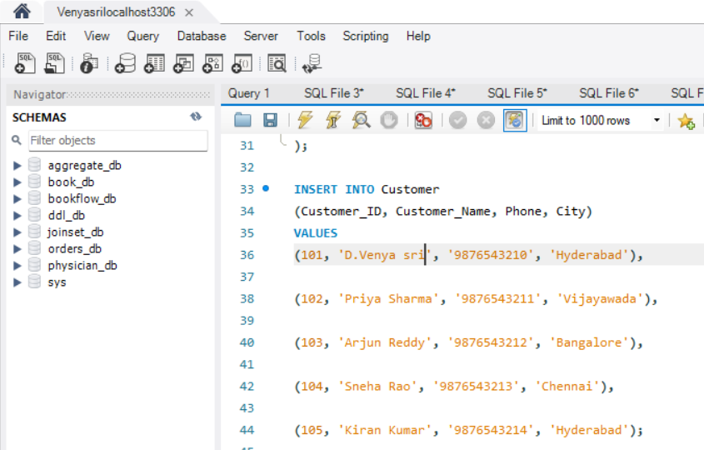
Output:

Query 6: INSERT ACCOUNT DATA
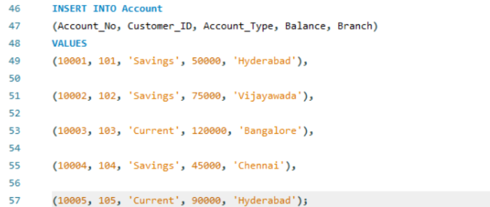
Output:

Query 7: INSERT BANK TRANSACTION DATA
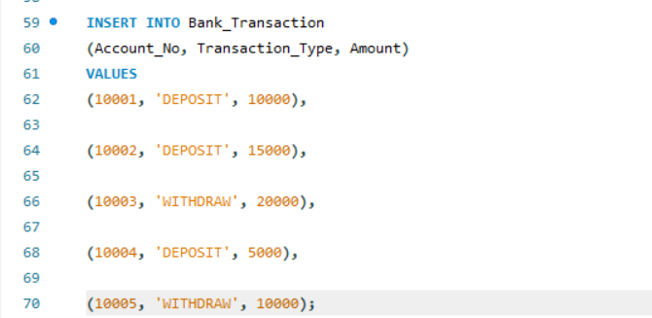
Output:

Query 8: DISPLAY DATA

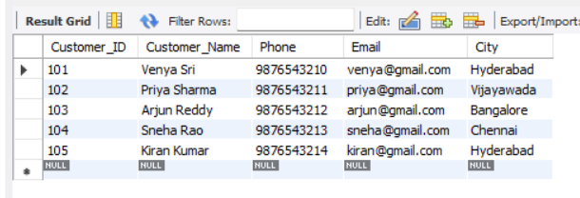
Query 9:

Output:
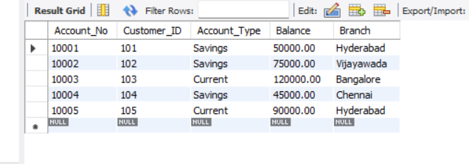
Query 10:

Output:
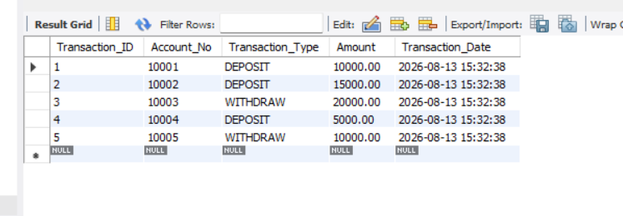

Query 11: START A TRANSACTION
Output:

Query 12: DEPOSIT MONEY
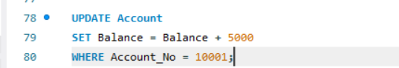
Output:

Query 13: CHECK BALANCE
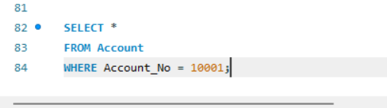
Output:
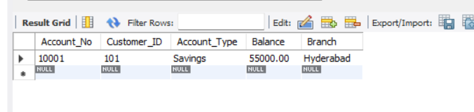

Query 14: COMMIT TRANSACTION

Output:

Query 15: CHECK BALANCE AFTER COMMIT

Output:
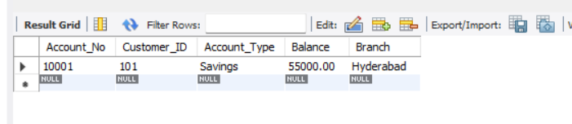

Query 16: START TRANSACTION
Output:
Query 17: WITHDRAW MONEY
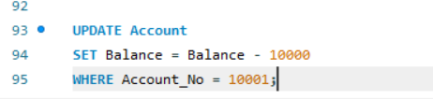
Output:

Query 18: CHECK BALANCE
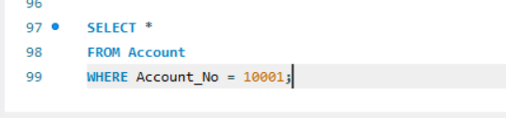
Output:
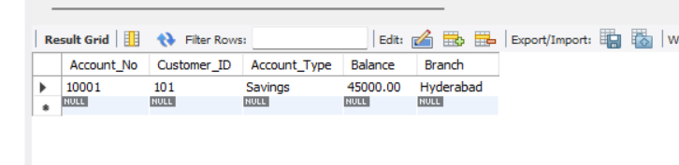

Query 19: ROLLBACK

Output:

Query 20: CHECK BALANCE AFTER ROLLBACK
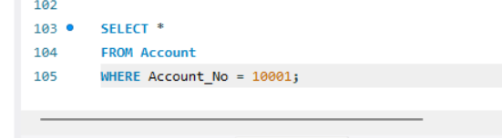
Output:
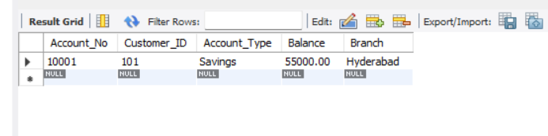

Query 21: START TRANSACTION

Output:

Query 22: FIRST UPDATE
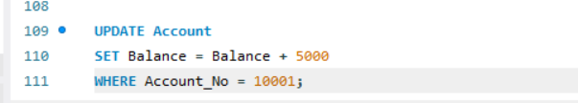
Output:

Query 23: CREATE SAVEPOINT
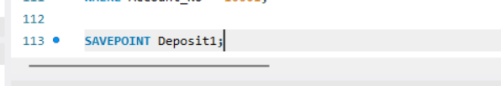
Output:

Query 24: SECOND UPDATE
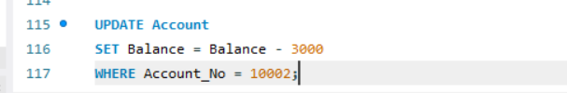
Output:

Query 25: CREATE SECOND SAVEPOINT
Output:

Query 26: THIRD UPDATE
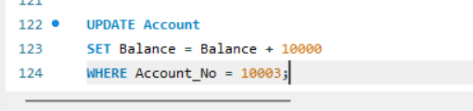
Output:

Query 27: ROLLBACK TO SAVEPOINT
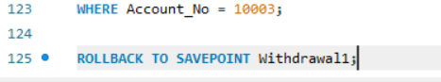
Output:

Query 28: COMMIT
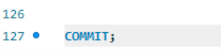
Output:

Query 29: CHECK ACCOUNTS
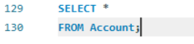
Output:
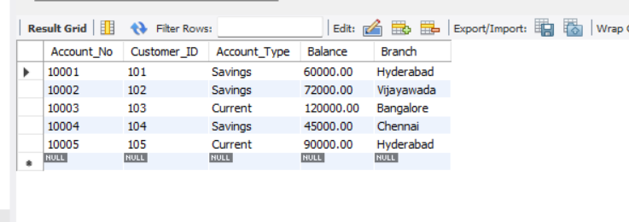

Query 30: TRANSFER MONEY
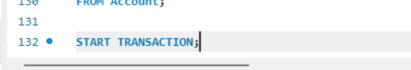
Output:

Query 31: DEDUCT FROM SENDER
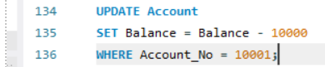
Output:

Query 32: ADD TO RECEIVER
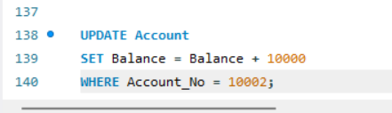
Output:

Query 33: CHECK BOTH ACCOUNTS
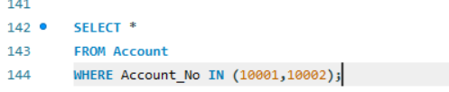
Output:
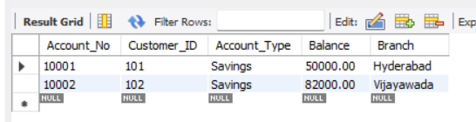

Query 34: COMMIT TRANSFER
Output:

Query 35: FINAL BALANCES
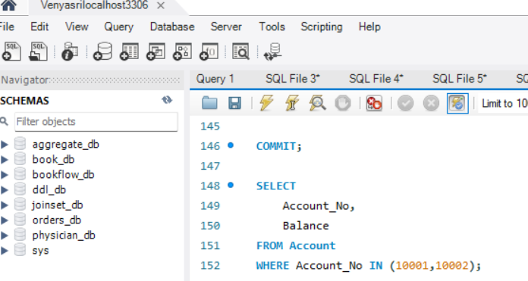
Output:
